# Homework: Bugs and Bug Tracking

## Bug Hunting: Google Home Page

You are given a picture of the **homepage of Google**, opened with a Google Chrome browser. Examine the picture and **list the errors you can detect at a first glance**. Then, you can open <https://google.com> for comparison and list the rest of the errors you have found after seeing it.

|  |  |
| --- | --- |
| **Bug** | **Description** |
| **Bug #1** | Missing Google button for search in side panel |
| **Bug #2** | Wrong placed Gmail button |
| **Bug #3** | Square button with Google applications is missing dot in it |
| **Bug #4** | Mismatched color of small g and l letters |
| **Bug #5** | Inverted magnifying glass button |
| **Bug #6** | Missing Search by Image button |
| **Bug #7** | Wrong font for location |
| **Bug #8** | Missing Advertising and Business buttons |
| **Bug #9** | Doubled How Search Works button |
| **Bug #10** | Missing Privacy button |
| **Bug #11** | Wrong Microphone icon in search bar |
| **Bug #12** | Missing Google favicon and tab name in the tab |
| **Bug #13** | Wrongly written “Feling” in I’m Feeling Lucky button |

## Bug Hunting: Notepad Application

One of the trainee developers has developed a **text pad** kind of application. Below is one of the screenshots of the application. Can you list out bugs/issues, which the trainee developer should take care of?

You can open Microsoft’s Notepad application for reference.

|  |  |
| --- | --- |
| **Bug #1** | Wrong icon |
| **Bug #2** | Missing file name |
| **Bug #3** | Missing Min and Max Window buttons |
| **Bug #4** | Wrong Close button icon |
| **Bug #5** | Missing View menu button |
| **Bug #6** | Missing Key combinations for Open and Print |
| **Bug #7** | Missing Exit button in File menu |
| **Bug #8** | Scrolling for right button is red |
| **Bug #9** | Missing up scrolling button |
| **Bug #10** | All first letters of the menu names are not underlined |

## Bug Reporting: Gmail

As a tester, the best part of the job is to report defects. We would like to know how you would report the following defect (you can decide upon the fields you want to include, while reporting the defect in the best way).

**Write a detailed defect report for this sample defect**:

“After logging into Gmail, it navigates to Google.com”

|  |  |
| --- | --- |
| **Bug ID** | GM-1 |
| **Priority** |  |
| **Severity** |  |
| **Assigned to** |  |
| **Reported by** | Merel Yumer |
| **Reported on** | 24.01.2023 |
| **Status** | Open |
| **Environment** | Chrome Version 109.0.5414.75 (Official Build) (64-bit)  Windows 11 Enterprise 22621.1105 64-bit operating system, x64-based processor |
| **Summary** | Wrong redirection |
| **Description** | After login into Gmail, it should redirect to Gmail inbox with emails, but it redirects to google.com |
| **Expected behavior** | After login into Gmail, it should redirect to Gmail inbox with emails |
| **Actual behavior** | After logging into Gmail, it navigates to Google.com |
| **Steps to reproduce** | 1. Open Chrome browser 2. Press Gmail shortcut button 3. Fill in email address and password 4. Press Sign in button |

## Bug Reporting: Reset Password

**Defect reporting for the following issue:**

* **Requirement**: After registering to the site – samplepage.com, a new user receives an e-mail, which contains a link to reset the default set password.
* **Issue**: When the user registers via mobile, he receives the e-mail two times.

**Log a defect report for this issue with all required defect report fields.**

|  |  |
| --- | --- |
| **Bug ID** | RP-1 |
| **Priority** |  |
| **Severity** |  |
| **Assigned to** |  |
| **Reported by** | Merel Yumer |
| **Reported on** | 24.01.2023 |
| **Status** | Open |
| **Environment** | Chrome Version 109.0.5414.75 (Official Build) (64-bit)  Windows 11 Enterprise 22621.1105 64-bit operating system, x64-based processor |
| **Summary** | Double receiving register confirmation email when register via mobile |
| **Description** | When register via mobile, user should receive one confirmation email, but he/she receives it two times. |
| **Expected behavior** | When register via mobile, user should receive one confirmation email. |
| **Actual behavior** | When the user registers via mobile, he/she receives the e-mail two times. |
| **Steps to reproduce** | 1. Open Chrome browser 2. Go to website samplepage.com 3. Fill in needed information for registration 4. Press Register |

## Register in Atlassian Jira Cloud

Create your own **Jira bug tracker online**: [https://www.atlassian.com/software/jira/free](https://www.atlassian.com/try/cloud/signup?bundle=jira-software&edition=free).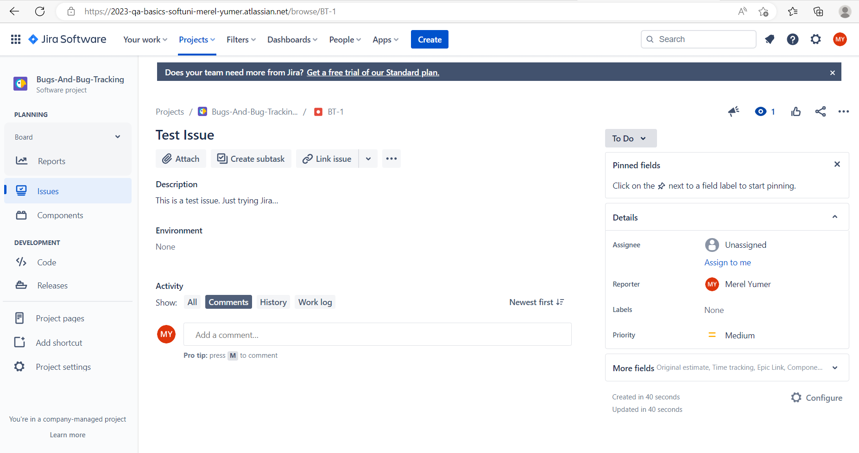

## Bug Reporting: Registration Form

As a software tester, what do you do? Of course, testing the software, you would say……… Okay, can you find out defects on the provided registration form?

<http://softuni-qa-loadbalancer-2137572849.eu-north-1.elb.amazonaws.com/registration-form-bugs/>

Keep in mind the following **field requirements**:

* **Username** consists of **no less than 6** **letters AND numbers**.
* E-mail should be valid e.g., something **/at/** something **/dot/** something
* **Password** should be **minimum 6 characters** and **maximum 12 characters**. **Uppers case, lower case, number,** and **special character** **required.**
* **Confirm password** should **match password.**
* **Clear Form should clear all fields.**
* **Create account redirects** to another page and **“You are now logged in.” message** should **appear.**

Report all bugs found in your Jira project.

* Use appropriate **title**.
* **Describe** the problem.
* Write the **steps to reproduce** the problem.
* Optionally, you may **attach** **screenshots** inBug-Tracking-Homework-FirstName-LastName.docx.

Report all bugs found in your Jira project.  
Optionally you may also describe bugs in the table below or **attach** **screenshots.**

|  |  |
| --- | --- |
| **Bug** | **Description** |
| **Bug #1** | Username less than 6 characters and without any numbers can be registered |
| **Bug #2** | Confirm password line name is Confirm Email |
| **Bug #3** | Clear Form does not clear all the lines filled in: |
| **Bug #4** | Create account redirects to “Thank you for registering.”, but not to “You are now logged in.”: |
| **Bug #5** | Wrong written account in “Create Your Acount”: |
| **Bug #6** | Password less than 6 characters can be registered: |
| **Bug #7** | Connection to website is not secure, it is not https |